**Menu Sortable:**

1. Create Menu Model, Controller, Migration using cmd: php artisan make:model Menu -mcr
2. Edit migration as below  
   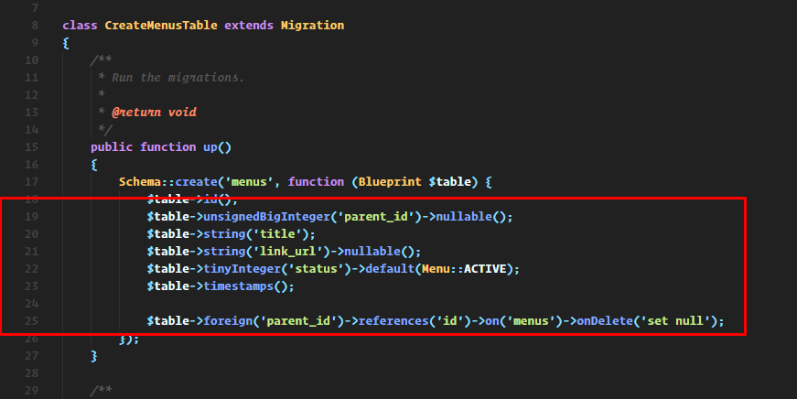
3. Menu Model  
   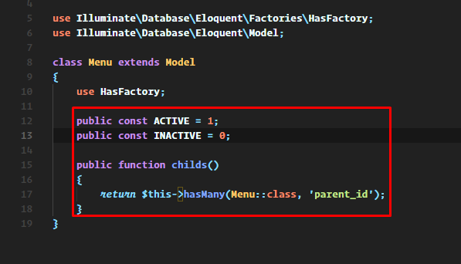
4. Menu Controller  
   See the ZIP (SEE THE sortable function)  
   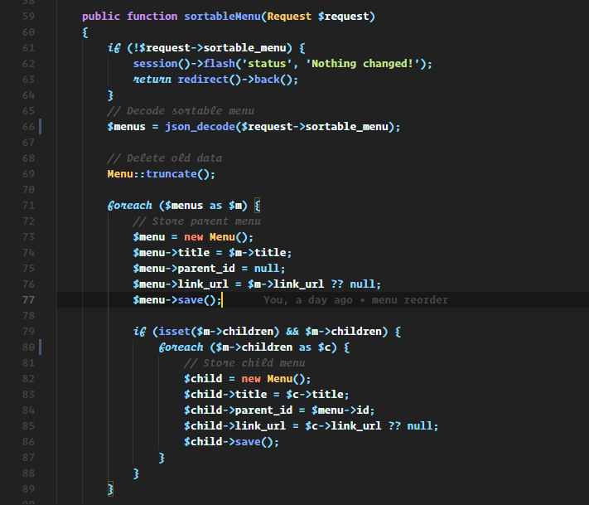
5. Create Views in menu folder  
   see the ZIP (SEE THE index.blade.php)  
   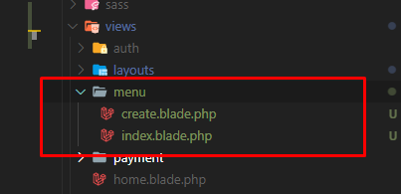  
   Check the index file where I add sortable and call to order the menu.
6. Add routes.  
   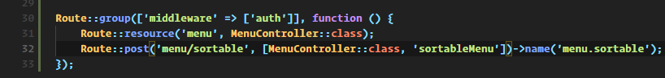
7. Edit App/Http/Providers/AppServiceProvider  
   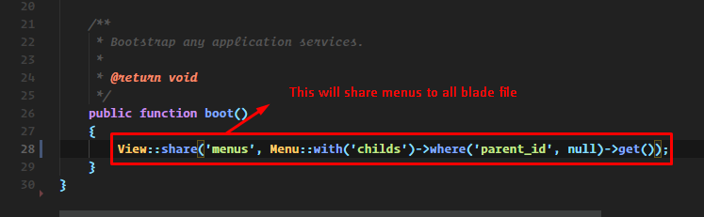
8. Then add the following in layouts/app.blade.php  
   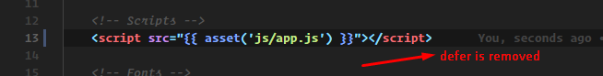  
   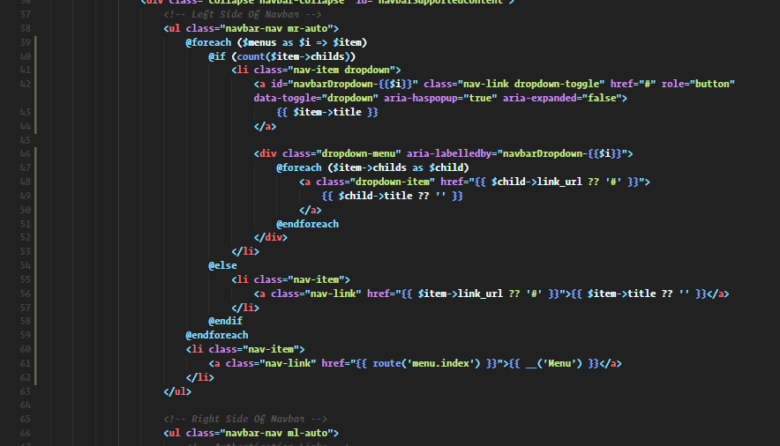
9. That’s it.